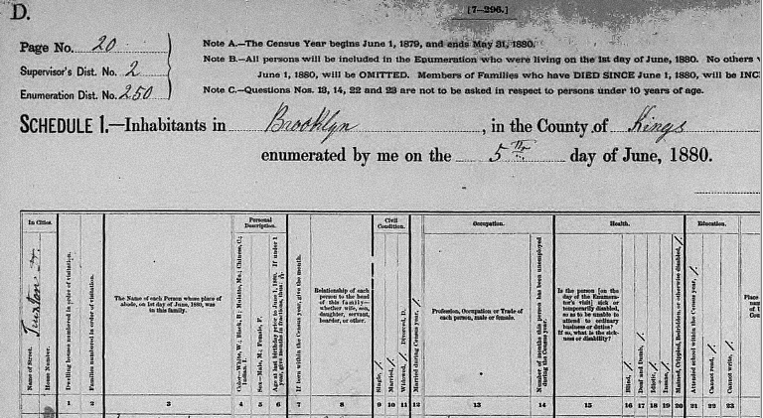
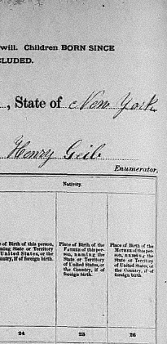
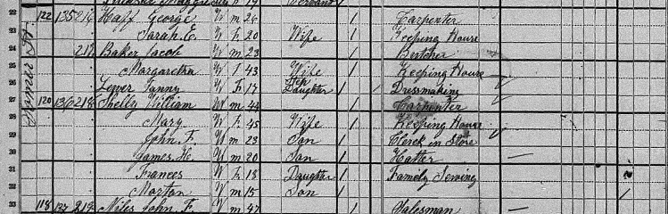
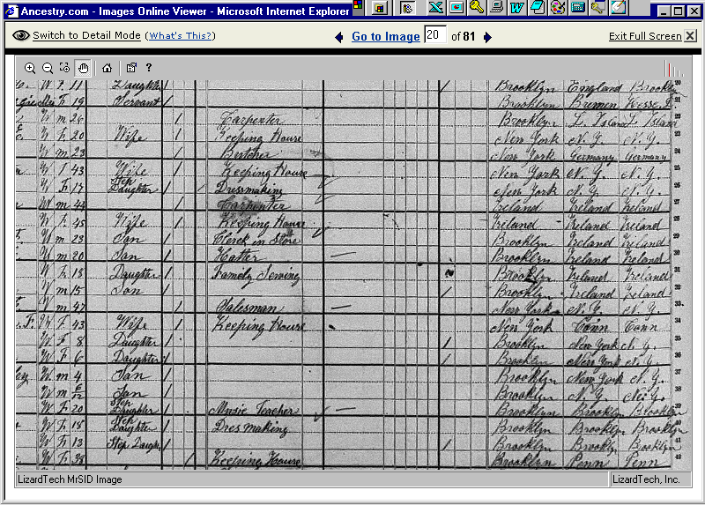
The Shelly and Delaney Household
1880 United States Federal Census
120 Somers Street
Brooklyn, Kings County, New York
T9 Roll 856 Page 166D ED 250
Mary, formerly Mary Delaney, is listed as the wife of William Shelly in this census. The children of Mary and Martin Delaney are most likely incorrectly enumerated under the Shelly surname. Documentation from periods after the 1880 census indicates that the children continued to use the Delaney surname after the marriage of Mary and William. Catherine Delaney had left the household by the time this census was taken. Martin is incorrectly listed as "Morton."

