http://glenparkassociation.org/

News from the Glen Park Association

October 26, 2014 · 8:16 am

A must-see Glen Park pumpkin tradition–Don’t miss it
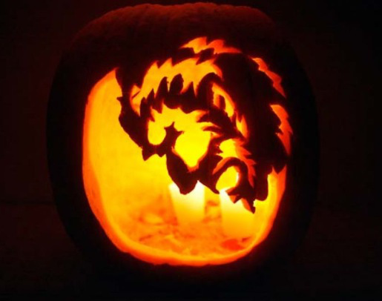For the last 19 years, starting in 1995 when they did their first 5 pumpkins, the Vella family of 354 Sussex has had a Glen Park tradition of carving pumpkins for 4 days before Halloween and putting out 40-60 pumpkins in front of the house on Halloween night.
It started out as a father-daughter bonding experience (Charlie & his now 4thyear UCSF medical student daughter Maya) and has become an annual tradition with lots of local Glen Park neighbors coming by to view each year’s carved pumpkin production.
While the Vella’s don’t claim any “particular artistic ability” in Charlie’s words, “we have gotten to be pretty good pumpkin carvers over the years.”
The pumpkins are amazing. Well worth walking up the hill to see.
YouTube video:

https://www.youtube.com/watch?v=CWHRUmjgllY

Here’s a Chron story from a few years back:

Gorgeous gourds / A San Francisco psychologist carves elaborate pumpkins in Halloween ritual

Arlene Silverman, Special to The Chronicle

Published 4:00 am, Wednesday, October 25, 2006

- 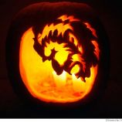
- 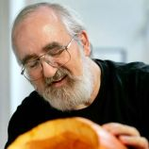
In a cozy family kitchen in San Francisco, a man with a sharp blade is on a mission. The man is Charlie Vella. The mission: to bring ancient history to the common Cucurbita pepo.
Vella, whose day job is director of neuropsychology services at Kaiser Permanente in San Francisco, is about to carve a handsome 1-foot-tall pumpkin into the likeness of an Egyptian pharaoh.
He is embarking on an annual tradition that started eight years ago, when he and his younger daughter, Maya, now a sophomore at UC Davis, became attracted to the art of pumpkin carving.
We're not just talking about smiley jack-o'-lanterns with those goofy triangular eyes. This father-daughter team has carved Harry Potter, Mr. Smith from "The Matrix," intricate African masks, Escher-like Irish knots, the Mona Lisa (whose enigmatic smile comes out just a little different each year), all those presidents on Mount Rushmore, King Tut and that other king, Kong.
Each year, Vella goes to Safeway and buys 10 or so pumpkins at a time. Then he and Maya, working over three or four days, carve 40 to 50 pumpkins. (They once tried to start five days ahead of Halloween, and the first batch "just melted away" before the big day.)
When the pumpkins are ready for display on Oct. 31, they are lit from within with votive candles and placed on the porch and stairs in front of the Vellas' Glen Park home.
Pumpkin carving itself, says Vella, is not difficult, but it does take a good eye for design, including the right combination of foreground and background, and the proper tools. In addition to using templates found on Internet sites featuring pumpkin-carving ideas, Vella is always on the lookout for fresh ideas.
He's found African masks in museums. He's taken designs off T-shirts and Japanese postcards. He generally avoids political subjects (no Osama bin Laden here) but did break his own rule once with a "Vote for Kerry" pumpkin during the 2004 election campaign. All the designs are applied freehand.
Although Vella is carving his Egyptian pharaoh on the kitchen table without his daughter (she's away at college), he and Maya usually carve in the living room while watching one of his large collection of horror films.
They start by carefully cutting off the top of the pumpkin and scooping out the seeds and pulp with a wooden scraping tool that Vella made himself. (Disposing of seeds and pulp from 50 pumpkins is no small feat. Sometimes the insides have to be taken to the dump lest the odor scare away trick-or-treaters.)
Using small cutting tools -- Vella describes them as "cut-off band saws" -- he cautiously saws away at the pharaoh he has already penciled on, using the inside of the pumpkin as a temporary trash receptacle for the carved-out pieces. The tools are designed, Vella says, so that the carver cuts the pumpkin and rarely himself.
From his biography, the 61-year-old would seem to have been an unlikely candidate as a husband, father and pumpkin artist. Born in Malta and raised in San Francisco's Bayview district when it was a "Maltese-Italian" neighborhood, Vella attended a Franciscan seminary for 10 years. He changed his career path, however, when he met his now-wife, Marilyn, and decided to put his pastoral bent to use as a psychologist, receiving his doctorate from UC Berkeley in 1978.
He says he's had no formal artistic training, although he once "built a pretty nice dollhouse" for his daughters. (Older daughter Lea, who recently married, is a biostatistician for the Veterans Administration. Marilyn, who is an avid quilter, works at UCSF.)
Vella says that he loves his day job at Kaiser. He also loves seeing "piles of kids" -- often as many as 100 -- come by his Sussex Street home on Halloween to see the creations. Like most city folks, he is sad to see that parents' concerns about safety have cut down on the number of trick-or-treaters. Nonetheless, the pleasure that passers-by get from seeing King Kong and Mona Lisa in the same place seems to compensate.
And even though the pumpkins last just a few days before they collapse like fainting divas, the cycle will begin again next year. "It's tradition," Vella says, smiling at the finished Egyptian pharaoh, who looks as if he just may smile back.

