

Van Bibber Newsletter

Vol. 8 No. 4

March 2006

Hello one and all! I want to thank everyone who answered my e-mails, and sent in news articles and photos for the new publication. It means a lot to Bruce and myself to know that everyone cares and takes such a great interest in the newsletter.
Jim put out a wonderful newsletter in January of 2005. We are all sorry that he was not able to continue.
Hopefully, he will be able to contribute, as we all will.
To start off this newsletter, I will introduce myself. My name is Patricia Ann Van Bibber-Santillan.

Isaac Van Bibber and Mariah Walraven
Loyal Van Bibber and Sarah Elizabeth Robinson
Albert Van Bibber and Phoebe Eakins
Charles Edison Van Bibber and Nellie Avery Waterman
Kenneth Carpenter Van Bibber and Opal Anna Barnes
Patricia Ann Van Bibber-Santillan

I have only been doing genealogy for about 2 years, and have lines of both parents back several generations.

At this time, I would like to welcome the newest members of the newsletter.
Pam Brewer: pbrewer2010@wowway.com
Jackie Stickels: jjstickels@aol.com
Lori Ann Bailey-Brookes: starryeyes1076@aol.com
John and Donna Tillis: dtillis@verizon.net
Elaine Trotter: trottere@sbcglobal.net

Again, welcome to all of you!

Happy St. Patrick’s Day

My wife was born Betty Jean PREAST in Zela, WV. Her Van Bibber ancestry chart looks like this in my records.
Gaymond Golden PREAST and Norah Virginia EWING
William Edward PREAST and Martha Ann DRENNEN
Charles Wesley PREAST and Reuhama Ann KEENAN
Robert KEENAN and Electra “Lecta” Caroline GROSE
Robert KEENAN and Olive Boone VAN BIBBER
Matthias “Tice” VAN BIBBER and Margaret Robinson GARDNER
Peter VAN BIBBER and Marjery BOUNDS
Peter VAN BIBBER and Anna?
Isaac Jacob VAN BIBBER and Frances SCHUMACHER
Jacob Isaac VAN BIBBER and Hester OP DEN GRAEFF

I would appreciate anyone having any additions and/or corrections to the above to contact me. I have the PREAST family recorded back to 1789.
Thanks for your efforts in this; they are really appreciated.

Joe Hahn: JosephHahn@aol.com

Hello all,
Well as bad as I hate to, I’m having my knee replaced tomorrow, Nov. 17, 2005. I don’t think this is going to be a happy day, although I am hoping it will be better later.
So I’m shutting down my computer until I get back on my feet or should I say my KNEE.
Love to all.

Nadine: dnduvall@sbcglobal.net

Dear Patty,
I am so glad to hear that the Van Bibber Newsletter is coming back to life. I have read all of the archived Newsletters. I am new to genealogy and have just discovered Letitia Van Bibber. At first I could not believe she was an ancestor, but after a few emails from Gary Hawpe and his sending a picture of Letitia VB, and then a few more emails from the descendants from the Maxwell family; I embrace as my own. In fact my son printed the email picture and made a photograph and now “Granny Lititia” sits on my desk.

Sincerely,
Jackie Stickels, Claremont, CA: jjstickels@aol.com

P.S. Letitia Van Bibbers daughter was my great grandmother, Cynthia Bolen, and my grandmother was Bettie Forester. So I want to be a member of the VB Newsletter.

Hello Patricia,
It’s great to hear from you. Will you be taking over as Editor? I really love the Van Bibber newsletter, and have truly missed receiving it. Below is a note that I am also forwarding on to a new Tillis cousin that just found me, and she was asking me about the newsletter so I know she will be writing to you and requesting to be put on the mailing list.

Barbara (Bailes) Mills: barbaramills2@comcast.net

Donna I just got this note from one of the Van Bibber’s. It looks like they may be starting the newsletter up again. Why don’t you write a request to be included on the list. to receive it? Just send your information from Clark Tillis & Mary Priddy down today.
You can also send the photo and information you have on LeRoy and his wife… and if you like, that large group picture because a whole lot of Tillis’ receive the newsletter and might be able to identify the people for you !!

Cousin Barbara

Hi Patricia:
Barbara Mills sent us an email with your address regarding the Van Bibber Newsletter. We sure would appreciate you adding us to your mailing list.

Our Lineage is:
Clark and Mary Margaret Priddy Tillis
LeRoy and Viola Victoria Harris Tillis
John W. and Donna LaRoche Tillis
John W., Jr. and Sara Roush Tillis
Alexander Tillis

We are also sending a couple of photographs. The one appears to be a school picture, but there are no names, dates, etc., however, it was in an envelope with other pictures of Roy, Viola and family. The other picture is of Viola and LeRoy Tillis.
Also, I don’t know if you have this in your notes, Bryan Tillis (brother of LeRoy Tillis) married Goldie Harris (Viola’s sister). Please feel free to email us with any questions. We will be happy to share whatever we have and answer any questions.

Thank you,
John and Donna Tillis: dtillis@verizon.net

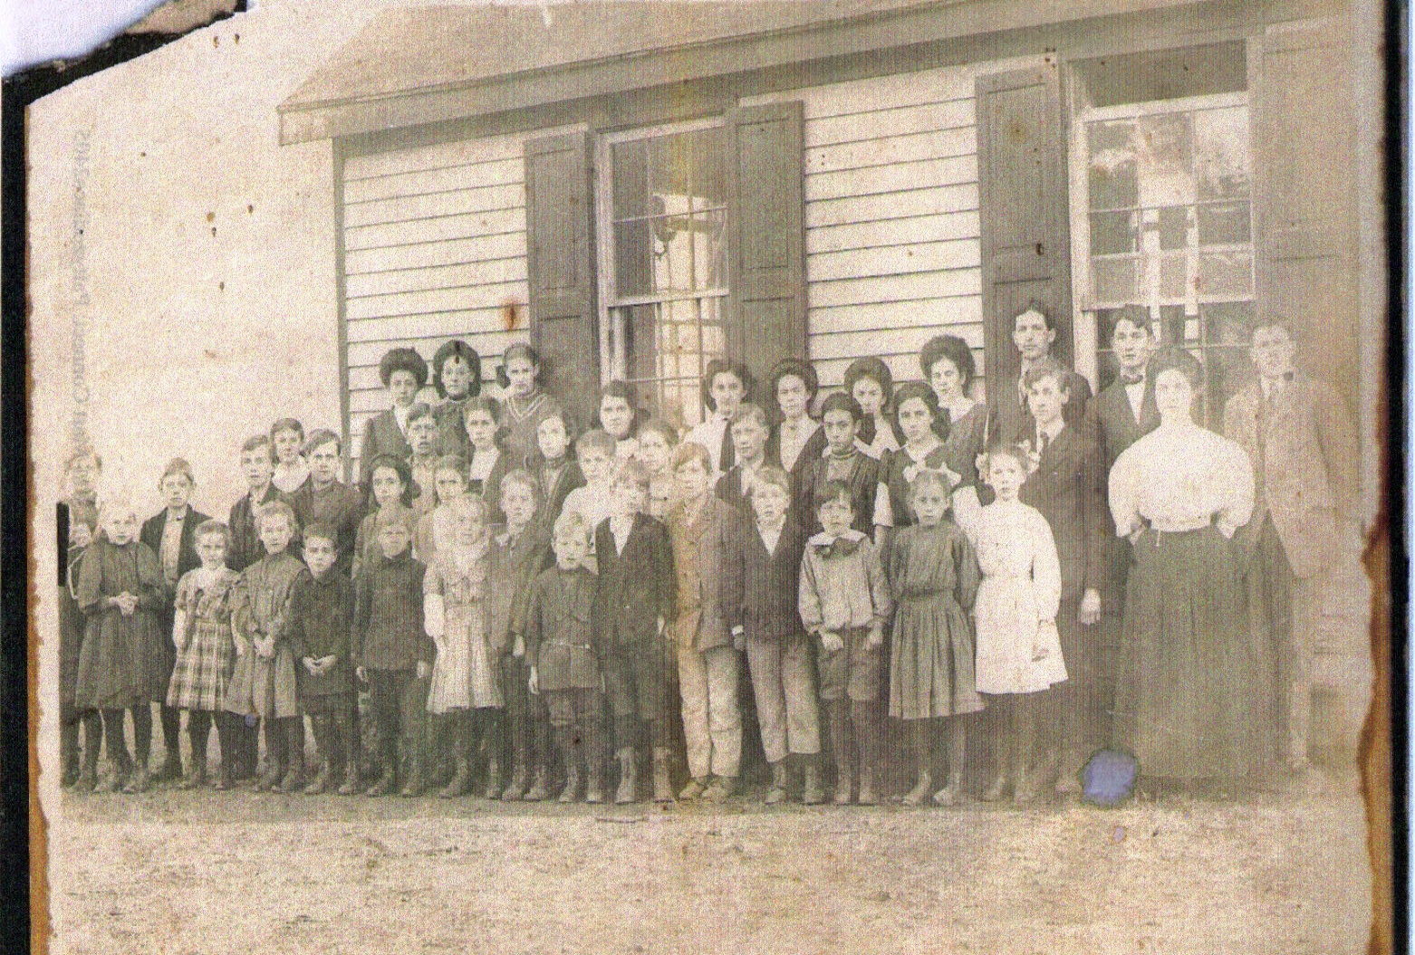

Group school photo “Tillis”

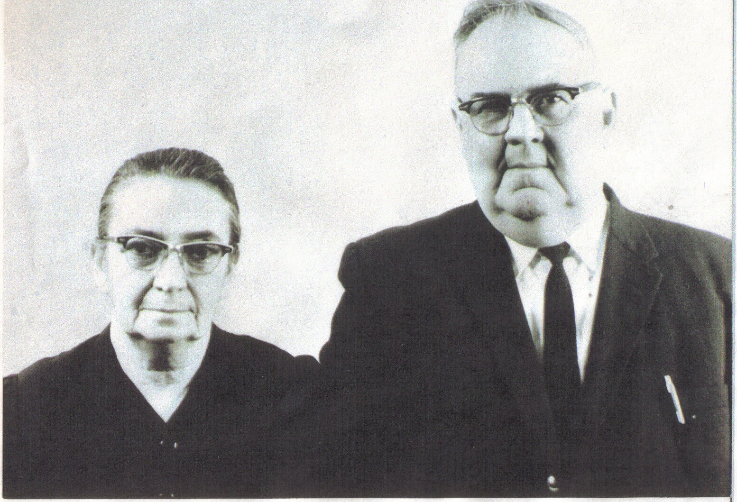

Viola and LeRoy Tillis

Descendants of Roy (Leroy) Tillis

1 Roy (Leroy) Tillis 1895 – 1965
+ Viola Victoria Harris 1898 – 1993
2 Mary Tillis 1918 –
2 Sherman Tillis 1919 – 1986
+ *Kathleen Jean Haley 1923 –
3 Sandra Tillis
+ Don Roger Smith
4 Don Roger Smith Jr.
3 June Tillis
3 Jerry Leroy Tillis 1945 –
+ Elenor Darlene Howard 1947 –
4 Wendy Leigh Tillis 1965 –
+ Edmund Thomas Giles 1961 –
5 Brandon Jo Thomas Giles 1988 –
5 Haley Marie Giles 1993 –
5 Hanna Leigh Giles 1995 –
5 Shane Howard Giles 1998 –
4 Gary Eugene Tillis 1968 –
+ Angela Unknown
5 Caitlin Renee Tillis
5 Justin Tillis
4 Jayson Leroy Tillis 1973 –
3 Kathy Jean Tillis
3 Mark Tillis
3 Louise Tillis
2 David Tillis 1922 –
2 Jonathan Tillis 1923 – 1997
+ *Pauline June Haley 1923 – 2002
3 John Willard Tillis 1943 –
+ Donna Mae LaRoche 1951 –
4 Cynthia Sue Tillis 1970 - 1970
4 John Willard Tillis Jr. 1971 –
+ Sara Beth Roush 1978 –
5 Alexander James Tillis 1998 –
4 Justin William Tillis 1977 – 1977
3 Danny Ray Tillis 1946 –
+ Saundra Dean 1948 –
4 Danny Mathew Tillis 1974 – 1974
4 Jayme Tillis 1973 –
+ Earl Bickford 1956 –
5 Bethany Bickford 2001 –
5 Samantha Bickford 2005 –
4 Donny Tillis 1975 –
3 Peggy Lee Tillis
+ Richard Earl DeWees
4 Tracy DeWees 1971 –
+ Allen Davidson
5 Amber Davidson
5 Dilan Davidson
4 Patrick DeWees
4 Scott DeWees
4 Brandon DeWees
3 Jeffrey Lang Tillis 1951 –
+ Debbi Hall Roush
4 Mike Roush
5 Jake Roush
4 Jodi Tillis
+ Wesley Young
5 Tory Tillis
5 Madi Tillis
4 Casey Tillis
3 *Denise Tillis 1955 – 1985
3 *Dennis Tillis 1955
+ Diane Gilmore
4 Adam Tillis
4 Dusty Tillis
3 Karen Sue Tillis
+ Bobby Roush
4 R. T. Roush
4 Clay Roush
3 Michael Tillis
+ Theresa Wildermuth
4 Zachary Tillis 1984 – 1985
4 Keisha Tillis
3 Timmy Todd Tillis 1963 –
2 Ruth Tillis 1927 -
2 Nellie Tillis 1929 –
2 Esther Tillis
+ Unknown Kennedy
3 Mary Kennedy
2 Amos Tillis
+ Ruth Unknown
3 Sue Tillis
3 Becky Tillis
3 Barb Tillis
3 Don Tillis
3 Joe Tillis
2 Curtis Tillis
2 William Tillis
2 Goldie Tillis

Notes: *Pauline June Haley and Kathleen Jean Haley were identical twins and married brothers. Denise and Dennis were also twins. Most dates above have not been verified but should be close.
Please use discretion with all family genealogical information. Protect and respect the interests of those still living. We should never post this information on public or paid for sites where those who have no interest are able to access this information.

Thank you,
Barbara Mills: barbarmills2@comcast.net

GOOD LUCK! Have missed the newsletter.
Was trying to find some clues in why the Walker family was in Barren Co., KY in 1779. The search is complicated by the fact that Barren Co. did not exist at that time, nor did KY. It was all a part of Jefferson Co., VA. Trying to find records is a problem. Anyway, I was going through a book, “The Personnel of George Rogers Clark’s Fort Jefferson And the Civilian Community of Clarksville [Kentucky] 1780-1781”. Based on the Lost Vouchers of George Rogers Clark by Kenneth Charles Carstens, (Published 1999), when I ran across a reference to Daniel Baber. As one of the many spellings of the Van Bibber family resulted in the surname of Baber. I thought you might be interested. I have no idea if this person is part of the Van Bibber family or not.
Excerpts from “The Personnel of George Rogers Clark’s Fort Jefferson And the Civilian Community of Clarksville [Kentucky] 1780-1781.
Based on the Lost Vouchers of George Rogers Clark; By Kenneth Charles Carstens. (Published 1999).

Baber, Daniel (also Babu) : 1/2/1780: Enlisted as Matross (Corporal) in Capt. Robert George’s Company of Artillery in the Service of the Commonwealth of Virginia and Illinois department (Harding 1981: 29-30)

6/12/80: Going to the Falls of Ohio with Capt. Harrison: George requests clothing issue for list of men who will be going on expedition. (VSA-11)

8/4/80: Deserted (Harding 1981:29-30)

Harding-- Margery Harding’s 1981 George Rogers Clark and his Mens Military Records, 1778- 1784
VSA-- Virginia State Library

Richard Walker: chloride@presys.com

Patty,
I submit a query trying to identify the following Van Bebber. Listed in MA records as “Captain”. Can anyone source him into the family tree?

DESCENDANTS of ISAAC VAN BEBBER

- Isaac Van Bebber + Elizabeth Trescot m: Oct 1734 in Boston, MA
2. Veronica Van Bebber (2nd wife of Isaac Van Bebber)
+ Elizabeth Harris m: 22 Jan 1737/38 in Ipswich, MA

Earl Harvey: erlzup@sbcglobal.net

I would like to receive the VB newsletter when it begins. I am a great granddaughter of Clark & Eleanor Ponster Tillis. (VB family).

Thank you Elaine Trotter: trottere@sbcglobal.net

Also: A recipe for GRANDMA TILLIS CAKE
I would love to pass the recipe on to anyone that would like it. I have one (cake) sitting in my kitchen aging for Thanksgiving day (minus one piece). I couldn’t wait.

Love, Elaine Trotter

(The recipe was forwarded t o Patty by Barbara Mills: barbaramills2@comcast.net)

From Elaine Trotter: Grandma Tillis (Mrs. Samuel P. Tillis from Onawa, Iowa) was 82 years old when she gave me the recipe in 1958, when one of my sons was born and she came to see him. That’s how long I have had it. She said it was her mothers before her. Grandma said they made it only on Xmas or if the preacher was coming for dinner. So the recipe was over a 100 years old then. Gran T. passed away in 1967 at over age 90. That recipe has to be pretty old. I know that it called for Butter, as they did not have shortening or oil as we know it. (I find that margarine works fine). I remember when I was little, seeing her bake on a kerosene stove that had an oven that sat over one of the burners, and she would make the most beautiful lemon pies.
The only thing Secret about it is that you should “age” it. Make it then let it sit a few days before you cut it. Wrapped properly, it will freeze also. This makes a large cake or two, as it calls for (4) square 8 inch pans, 2 inches deep.
GRANDMA TILLIS CAKE
Mixing this cake takes about 25-30 minutes.

1 ½ cups butter or margarine 2 cups sugar (white)
6 eggs 3 ½ cups cake flour (I sift)
2 teaspoons baking soda 2 teaspoons ground allspice
2 teaspoons cinnamon 6 tablespoons buttermilk
2 cups of Strawberry Jam
Cream the softened butter. Add sugar slowly, beating till creamy.
Add eggs ( room temperature) one at a time; beat well after each egg.

Have flour mixture ready, sift flour and sift again with soda and spices. (Measure flour after sifting). Add flour, alternating with the buttermilk; mix well to blend.
Last of all, Fold in the Strawberry Jam. (If any pieces of strawberry are large, chop them up). Brush the bottoms (only) of the cakes pans with shortening or salad oil. Pour batter into pans; level with a spatula. Drop on the table a couple of times to remove air bubbles.
Bake in moderate oven (375) for 30-40 minutes or till done. Cool on cake rack then turn out to cool before icing. Frost with uncooked Caramel Icing.

UNCOOKED CARAMEL ICING

1 ½ sticks butter ½ cup of cream
2 cups dark brown sugar (for rich caramel flavor 2 teaspoons Pure Vanilla
½ teaspoon of salt Powdered (confectioners) sugar;( just enough to make a spreadable consistency)
Melt the butter and cream together, while hot stir in the brown sugar. Cool ad stir in the vanilla. Stir in the salt and add Powdered sugar as needed to get a spreadable frosting. This will thicken up fast. (I use the mixer but, add Powdered sugar slowly).
This seems like a lot of work when we use mixes but it is so worth the effort, and the recipe can be cut in ½ to make a smaller cake.

Elaine Trotter: trottere@sbcglobal.net

Hi Patty,
Below is a bio I compiled on Jacob Isaacs Van Bebber and another bio on his daughter, Lisbet Isaacs Van Bebber, from whom I descend. I would be interested in finding out if anyone has developed any more information on Jacob or Lisbet, or have any corrections to make to this compilation. Has anyone found Jacob’s parentage?

Larry P. Cornwell: LaCornwell@aol.com

(Jacob Isaacs Van Bebber > Lisbet Isaacs Van Bebber > Elsabet Op de Graef > Ankin Bon > Peter Van Fossen > Jacob Van Fossen > Elizabeth Van Fossen > Jacob Lambert > Francis William Lambert > Carrie Inez Lambert > Francis Lambert Kerr > Madelyn Frances Kerr > Larry Patrick Cornwell)

Jacob Isaacs Van Bebber was born ca. 1640 in Krefeld, Cuchy of Cleves, Lower Rhineland, present day Germany (a few miles from the Holland border). He died in Philadelphia Sept. 7, 1705, around the age of 65.
His wife was Christiana? He immigrated to America in 1687, three years after his sons.
According to S.W. Pennypacker in The Settlement of Germantown, Pennsylvania, 1899, pages 3 and 16:
“On the 11th of June, 1683, Penn conveyed to Govert Remke, Lenart Arets, and Jacob Isaacs Van Bebber, a baker, all of Crefeld, on thousand acres of land each, and they, together with Telner, Streypers, and Sipman, constituted the original Crefeld purchasers. It is evident that their purpose was colonization, not speculation. Of the six original purchasers Jacob Telner and Jacob Isaacs Van Bebber are know to have been members of the Mennonite Church.”
The first services of the Mennonites and Wissahickon Pietists were held in his house in 1690.
Pennypacker continued, on page 254:
“A charter of incorporation [for Germantown], dated May 31, 1691, was issued to Francis Daniel Pastorius, bailiff; Jacob Telner, Dirck op den Graeff, and Tones Kunders, burgesses; Abraham op den Graeff, Jacob Isaacs Van Bebber, Johannes Kassel, Heifert Papen, Hermann Bon , and Dirck Van Kolk, committeemen, with power to hold a court and a market, to admit citizens, to impose fines, and to make ordinances.”
According to W.I. Hull in William Penn and the Dutch Quaker Migration to Pennsylvania, 1935, 1970, page 403, reprinted in the Mennonite Family History, Vol. XII, No. 4 in an article entitled The Van Bebber/Van Bibber Family by David V. Stinson, Esq.
“Van Bebber was “pro-Keith”, but reverted to Mennonites and moved to “High Street,” Philadelphia, before 1698.”
Pennypacker, on page 176, stated that Jacob Isaacs Van Bebber was the first Recorder of Germantown (1691) and a burgess there in 1692. He owned the lower half of Lot No. 9 on the west side of Main Street, Germantown, in 1689. He was listed as a church member May 23, 1708.
He was buried under the floor of St. Stephen’s Chute, Earleville, Cecil County, Maryland.

The children of Jacob Isaacs Van Bebber and Christiana were:
- Lisbet Isaacs, b. 1643, m. Herman Isaacs Op den Graeff, d. 1684
- Isaac Jacobs, b. ca. 1661, m. Fronka Peterson in 1684, d. between Sep 14-Nov 25,1723 (age abt 62)
- Matthias Jacobs, b. 1663, m. Hermana Peterson on Nov 17, 1705, d. bet Aug 3-Oct 1, 1739
- Henry, b. 1665, m. Catherine Ann Bougard, buried May 31, 1733
- James, b. 1667, m. Samoa?, d. 1750
- Deborah, b. 1660 or 1669, m. 1st Herman Op den Graef (husband of sister Lisbet) on May 7, 1691; 2nd, Dirck Keyser, Jr. d. 1701
- Margaruite, b. 1671, m. Jurriaen Beal

Lisbet Isaacs Van Bebber was born ca. 1660 in Krefeld, Lower Rhineland, (present day Germany) and died in 1684 in Pennsylvania around the age of 24.
Her husband was Herman Isaacs Op de Graef. He was born in 1642 in Krefeld, Lower Rhineland (present day Germany and died before May 2, 1704 in Knet County, Delaware about the age of 60.
His second wife was Debra Van Bebber, whom he married on May 7, 1691 in Germantown, Pennsylvania. She was born in 1660 and died in 1701 in Kent County, Maryland. She was a sister of Lisbet.
Lisbet Isaacs Van Bebber and her husband Herman Isaacs Op de Graef were among the first thirteen Krefeld families arriving in 1683. Their children were:

i Elsabet. B. ca. 1680, m. Peter Bon, d. ca. 1711
ii Margret, b. 1667, m. Peter Schumacher on Feb 6, 1697, d. Jul 14, 1748

Debra Van Bebber and Herman Isaacs Op de Graef had the following children:

i Sytge, b. 1685, m. 1st, Jan Krey; 2nd, Hubert Cassel
ii Isaac, b. 1693, m. Rachel Linton, d. 1747

Dear Patty,
Thank you so much for your email, and thank you for adding me to the list. I will try to contribute what little bit I can.
Campbell County, TN is publishing a “Family Reunion “ book, ($45.00) I think. No Van Bebbers in it, but I did notice some related names. Maybe someone will be interested.

Thanks,
Your Cuzzin
Pam Brewer: pbrewer2010@wowway.com

BIRTHS

Hello Patty,
Glad to hear that we are working on getting more publications. I’ll try to get more info for you all but I am “married in to the line so it is more difficult to get the personal info and which is so interesting. Thanks again.
We have a new twig on the Van Bibber Family Tree. NOLAN WILLIAM CUELLAR was born at the University of Michigan Hospital, Ann Arbor, Michigan to William Joseph Cuellar, Jr. and Karen Joan Bergboweron on October 3, 2005. He weighed 7 pounds, 12 ounces, and was 22 inches long. Nolan descends from two branches of the Van Bibber family and is a 5th great grandson of John Liford and Levicy Van Bebber. The lines are as follows:

Isaac VanBibber and Sarah Davis; Peter VanBebber and Ellinor VanBibber; Levicy VanBebber and John Liford; Lazarus Liford and Elizabeth “Becky” Hackworth; Hiram “Hick” Liford and Sarah “Sally” Sulfridge; George Washington Liford and Caldona Upton; John Tip Liford and Emily Jeanette Ball; Patricia Ann Liford and William Joseph Cuellar; William Joseph Cuellar, Jr. and Karen Joan Bergbower; Nolan William Cuellar—and—Peter VanBibber, Jr. and Marguery Bounds; Ellinor VanBibber and Peter VanBebber; etc.
Submitted by Joan Humphreys Bergbower: joanb@netone.net

DEATHS

Patty,
It is wonderful that you will continue this important deed.
My sister Betty Lita Castro Beckwith (married to Gustavo Flores) died February 23, 2005 in Queretaro, Mexico, at the age of 63.
She had a battle with breast cancer. After three chemotherapy’s, she decided that she would embrace the unconventional treatment which allowed her quality of life and a peaceful passing.
Betty was an extraordinary person, highly spiritual, talented and gifted in many areas. Among her life accomplishments she was an art critic, a business woman, an anthroposophist and a dedicated mother of two beautiful daughters, Ana Maria and Cristina. She left a great legacy and will always be remembered with admiration, respect and a great deal of love.
She was the first born of Joseph Daniel Castro Castagnetto and Ana Maria Beckwith Becerra. Ana Maria was the great granddaughter of Ezra Jeffords and Elizabeth Van Bibber. Betty was the oldest of six children born to Joseph and Ana Maria.

Best regards.
Your distant cuz, Marian Shearer (2nd on line) : rbms91@hotmail.com

FRED VAN BEBBER
Isaac VanBibber and Sarah Davis
Peter VanBebber and Elinor VanBibber
Jacob VanBebber and Catherine Ann Guthrie
Calvin VanBebber and Barthena A. VanBebber
William Franklin VanBebber and Eliza Ramsey
Frederick Earl Van Bebber and Lucia Emma Morgan
Frederick Earl Van Bebber, Jr. and Linda Elledge

Fred E. Van Bebber, Sr. died December 6 in a San Francisco hospital at the age of 70 years.
A lifelong resident of Willits, Mr. Van Bebber was a retired Willits City employee and a member of Little Lake Grange.
Survivors include his widow Lucy, of Willits; a son, Fred Jr., of Placerville; a sister, Bertha Cleveland of Ukiah; three grandchildren and numerous nieces and nephews.
Funeral services will be held at Anker Lucier Mortuary at 11 a.m. Saturday, December 11 with internment following at Willits Cemetery.

The Willits News, Willits, CA., Wednesday, December 8, 1976.
[Note: Fred Van Bebbers date of birth is October 6, 1906]

FREDERICK VAN BEBBER, JR.
Graveside services were held at the Willits Cemetery on September 19 for Frederick Earl Van Bebber, Jr., who died on September 16 at the age of 54.
Mr. Van Bebber was born and raised in Willits and was a graduate of Willits High School. At the time of his death he was a supervisor in the Cal Trans Transportation office in Sacramento, and was living in Pollack Pines.
He is survived by his mother, Lucia Van Bebber of Willits, and his wife, Linda Van Bebber of Pollack Pines.
Mr. Van Bebber is also survived by his sons, David Van Bebber and Dale Van Bebber, both of Pollack Pines; and his daughter, Dawn Amstutz, and two granddaughters, all of Idaho.

The Willits News, Willits, CA. Wednesday, October 7, 1987. Page 6.
[Note: Frederick Van Bebber, JR’s date of birth is June 17, 1933]

MARJORIE N. GILLEY
Isaac VanBibber and Sarah Davis
Peter VanBebber and Elinor VanBibber
Jacob VanBebber and Catherine Ann Guthrie
Calvin VanBebber and Barthena A. VanBebber
William Franklin VanBebber and Eliza Ramsey
Bertha Elizabeth Van Bebber and George Washington Cleveland
Marjorie N. Cleveland and Curtis C. Gilley

A graveside service for former Ukiah resident and business owner, Marjorie N. Gilley is scheduled for 10:30 a.m. Tuesday at the Ukiah cemetery.
Mrs. Gilley died Thursday, September 2, 2002, at home in Rogue River, Ore., after a long battle with cancer. She was 72.
Born on October 26, 1929 in Eureka, she married Curtis C. Gilley on June 27, 1948.
He preceded her in death on September 5, 1992 after 44 years of marriage. The couple lived in Ukiah for many years, and Mrs. Gilley worked for Hollow Tree Lumber Company. Later, she and her husband owned Gilley’s Shell Station on Perkins Street and Gilley’s Seafood. In 1991, they retired to the Rogue River Valley in Oregon.
Mrs. Gilley is survived by her daughter, Yvonne R. Gilley of Santa Rosa; a grandson, Joshua C. Stemich of Milwaukee, Oregon; a sister, Ellamay Murray of Cloverdale; three nieces and two nephews.
Remembrances may be made in her name to Asante Foundation/Hospice Services; 2960 Doctors Park Drive; Medford, Oregon 97594.
Eversole Mortuary is in charge of the arrangements.

Ukiah Daily Jouranal, Ukiah, CA. Sunday, September 16, 2002
[Note: Marjorie is buried in Evergreen Memorial Gardens; 141 Low Gap Road; Ukiah, CA next to her husband, which is also near her parents.]

LUCY VAN BEBBER
Willits resident, Lucy Emma Van Bebber died at her home on February 19 at the age of 77. A native of Cedarville, Mrs. VanBebber lived in Willits most of her life.
She is survived by her daughter-in-law, Linda Van Bebber of Pollock pines, her sisters Millie Barolomei of Ukiah and Bernice Morgan of Santa Rosa, and her brother James Morgan of Milton Sweetwater, Oregon.
She is also survived by three grandchildren, three great grandchildren and numerous nieces and nephews.

The Willits News, Willits, CA. Friday, February 24, 1989; page 4.
[Note: Lucy Van Bebber’s date of birth is May 3, 1911.]

Submitted by: Ted & Sharon Van Bebber: tjvanbeb@sbcglobal.net

Hello,
I’m writing to let you know we lost another cousin Christmas 2005. Kenneth Thatcher, of Muskogee, OK. Passed away at 9:55 p.m. after spending the day with all of his grandchildren and great grandchildren.
I’m sorry to be the one that always has bad news.

Love Ya,
Nadine: dnduvall@sbcglobal.net

COMMENTARIES

(Most of the following are in reference to Bruce and I trying to get the Newsletter going again.)

Hi Patty,
This is great news…Have really missed the newsletter.

Ruth Bailes: rjbailes@earth1.net

Patty,
After receiving your email, we are more thankful this Thanksgiving. We’re so happy the VB newsletter has been reactivated. We really missed submitting and reading. Thank you.
We will get news articles to you promptly.
Thanks again to you and Bruce for your VB efforts.
Ted & Sharon Van Bebber; San Rafael, CA: tjvanbeb@sbcglobal.net

Patty,
Thank you.

Earl H Taylor: eht2060@keyway.net
Yahoo IM eht2060
AOL IM eht2060
http://www.keyway.net/-eht2060

So Happy to hear this. I’ve really missed the newsletter.

Donna Van Bebber-Willis: naxopana@yahoo.com

Good News! I am looking forward to it and certainly want you to know I appreciate your efforts on our behalf.

Sherry Rollins: Rollins@atmo.arizona.edu

Don’t have any news. But wanted to take the time to say “Thank You” for your’s and Bruce’s efforts.
I very much enjoy the Newsletter, and have found great information on my family genealogy.
Thanks again.
I have included my web site with my e-mail’s genealogy. My grandfather was Francis Marion Tate Fulfer, and he is my tie to the Van Bibber’s. I have over 2400 family members recorded. If you care to add my link to the Van Bibber Family site, you have my permission.
I have not done genealogy research. I have only recorded information recorded by others and given to me.
Thanks again and have a great day.

Lawrence Dale Lane: dale@orenaconsstruction.com
Http://familytreemakeer.genealogy.com/users/l/a/n/Dale-Lane-TX/index.html?Welcome=1078934044

Thank you both for trying to get the newsletter back up and going again.
I have a new e-mail address.

Marty Belt: mbelt@austin.rr.com

