
VANBIBBER NEWSLETTER

Vol. 8, No. 5
April 2006

Hello again!

Well, I finally got the newsletter out to everyone. I’m sorry that it took so long. I won’t give any excuses or reasons for the delay. I’m just glad that I was able to complete it.



WELCOME TO OUR NEW MEMBERS!

Kay Goforth-Adams: adam9419@bellsouth.net
Annette Brown: abrown4431@comcast.net
Debra Lloyd: Leighlloyd@wmconnect.com
Michael Metford-Platt: metfordplatt@telkomsa.net
Chuck Wolfram: cwolfram@prodigy.net
Sue Olsen: Jolsen48@emerytelcom.net

Patty,

I am Kay Goforth-Adams.

I was an old member of the Van Bibber list, and would like to join again in getting the newsletter.

My connection is as follows:

DESCENDANTS OF JOHN M. VANBIBBER

Generation No. 1

- John M. (1) VanBibber was born Oct 25, 1819 in Roane Co., TN, and died March 11, 1865 (Killed by cousin in late Civil War). He married Manerva Jane Kincaid April 15, 1843 in Claiborne Co., TN; daughter of William Kincaid and Susan Wilson. She was born June 27, 1824 in Powell Valley, Claiborne Co., TN, and died April 10, 1856 in Claiborne Co., TN.

Children of John VanBibber and Manerva Kincaid are:

  - William M. (2) VanBibber, b. Feb. 13, 1846, Claiborne Co., TN; m. Mary A. Jones, Feb 22, 1871, Claiborne Co., TN.
  - Mary Jane VanBibber, b. Dec. 8, 1847, Claiborne Co., TN; d. Oct. 15,1920, Bell Co., KY.
  - Susan Leann VanBibber, b. Oct. 21, 1849, Claiborne Co., TN. d. July 13, 1876, Campbell Co., TN. M. John Miller Claiborne, abt. 1869, Roane Co., TN.
  - James Madison VanBibber, b. Jan. 5, 1852
  - Nancy Tennessee VanBibber, b. Sept. 19, 1855; m. Lahue E. Jones, abt. 1882, Claiborne Co., TN.

Generation No. 2

2. Mary Jane (2) VanBibber (JohnM.1) was born Dec. 8, 1847 in Claiborne Co., TN,
and died Oct. 15, 1929 in Bell Co., KY. She married Jesse Goforth Nov 1, 1873 in
Claiborne Co., TN. He was born abt. 1853 in Claiborne Co., TN.

Children of Mary VanBibber and Jesse Goforth are:

- Susan A. (3) Goforth, b. abt 1874, TN.
- William Goforth, b abt 1876, TN.
- John M. Goforth, b. abt 1878, TN.
- James Alvis (B) Goforth, b. Jan 6, 1878, TN.; m. Alta Vermillion
Goodin.
- Oscar Goforth, b. abt 1881
- Lillie Goforth, b abt 1885; d. 1886
- Infant Goforth ; born and died 1886
Surnames of NE Tennessee: Goforth, Van Bibber, Kincaid; Wilson’s in Union and Claiborne Co.

Surnames of Bell, Knox, and Clay Co., KY: Goodin, Hendrickson, Asher, Bowling, Pfaff, Downey, Collett, Davis

P.S. (Thanks for any help on my line)
Kay Adams: adam9419@wmconnect.com

Can anyone ID the VAN BIBBER this tavern was named after? From the following web-
page: http://digital.lib.ecu.edu/historyfictionsearch.aspx

Pocotaligo, 76.3m (5alt. 317 pop.) is a tiny village whose history goes back to the earliest settlement of the section, when one of the large towns of the Yamasee Indians and an Indian trading post were here. The first blow of the massacre of 1715 was struck here, several hundred whites being killed. Others, warned by a wounded seaman who swam across the Pocotaligo River, escaped by fleeing to a vessel that lay in Port Royal harbor. Being on the direct route between Charleston and Savannah, Pocotaligo was later a stagecoach stop, and the former Van Bibber’s Tavern entertained many notables.

During the Revolution, the British occupied Fort Balfour, which was here;; on April 13, 1781, without a shot having been fired, it was captured by Col. William Harden, a follower of Francis Marion. Members of the Colonial militia, who had been forced by the British into the defense of the fort, recognized their friends in the handful of attackers and refused to fire on them.

During the Civil War the town was the scene of a number of skirmishes resulting from the efforts of Union soldiers to destroy the railroad between Charleston and Savannah. The town was held by the Confederates until January 14, 1865, when it was abandoned at the approach of Sherman’s army.

Earl Harvey: erlzup@sbcglobal.net

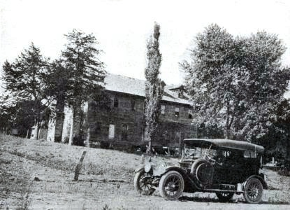

PHOTO OF THE VAN BIBBER TAVERN IN MINEOLA, MISSOURI

Submitted from files: Patty V. B.

Patty,

Probably not all Van Bibbers etc. know that the first ones were Mennonites and that they came to America at the invitation of William Penn and helped establish Germantown, now part of North Philadelphia. The Van Bibbers fought and died at battles of Kings Mountain and Point Pleasant leading up to Revolutionary War.

My wife’s ancestors lived in Augusta Co., VA in early 1700’s and were neighbors of my Taylor ancestors. I met my wife in CA and we were married in NV.
It’s a small world.

Earl H. Taylor: eht2060@keyway.net
(909) 593-2652
yahoo IM eht2060
aol IM eht2060 and http://www.keyway.net/~eht2060

Hey to all you cousins,

This is Debra Lloyd. (Homer VanBeber, Sr. & Louise’s baby daughter). I live in Winston-Salem, North Carolina.

I would like to keep in contact with those of you who knew my parents and who may remember me. I have some photos that I inherited when Mama died (Oct. 6, 2001) and there may be some of you in there.

I know that Andy Gaylor is, or I think it’s him. I also have some of others, who I cannot identify, but would like to. If you are interested in keeping in contact with me, I can be reached at: (336) 924-3993 HOME or (336) 816- 4442 CELL

Debra Lloyd
4650 Shattalon Circle
Winston-Salem, NC 27106

Hope to hear from You!
Love,
Your cousin
Debra Lynn VanBeber-Lloyd: Leighlloyd@wmconnect.com



THE STOVER FAMILY
These two photos are of Mary Pontsler. She is my sister-in-law’s
Gggrandmother. My sister-in-law is Sharon Faye Stover Bailes;
(who is the daughter of Lloyd Stover & Minnie Garrison).

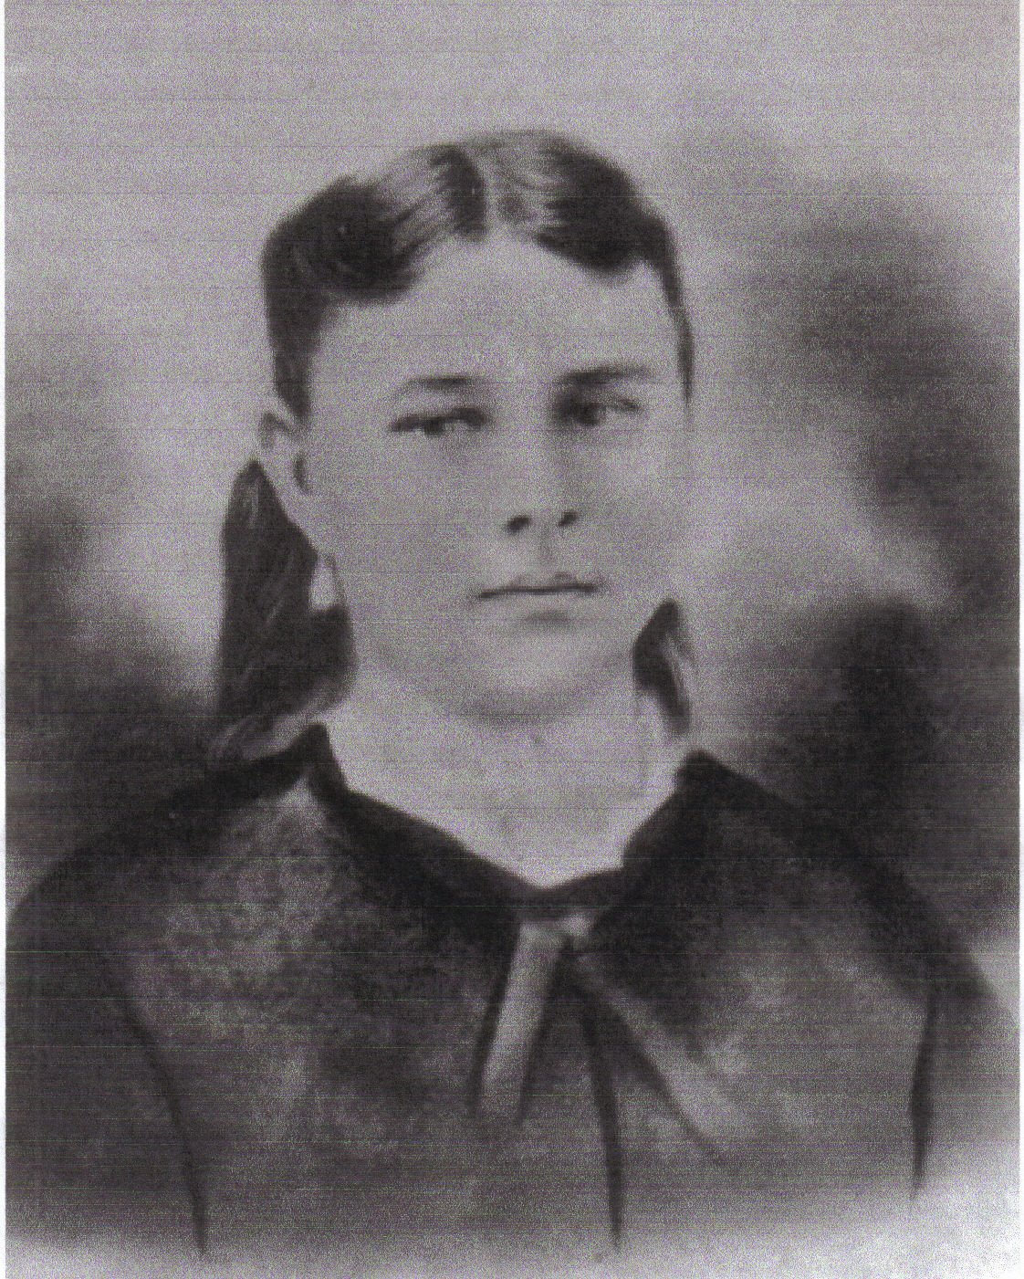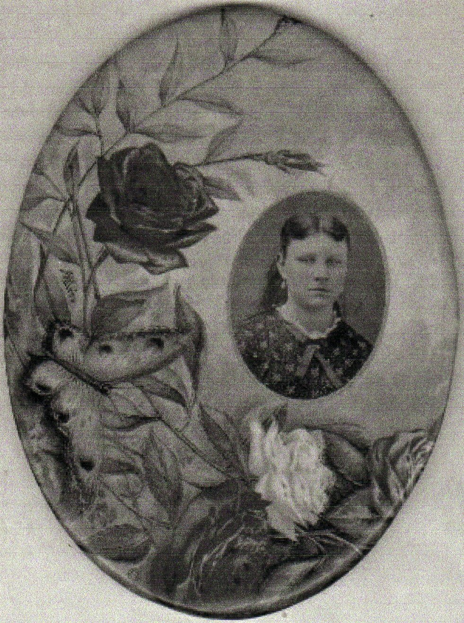

This is a photo of Joseph This is a photo of Virginia Dares
Stover; taken in Oklahoma. Corn. She is the daughter of
Charles Curtis and Eva Stover

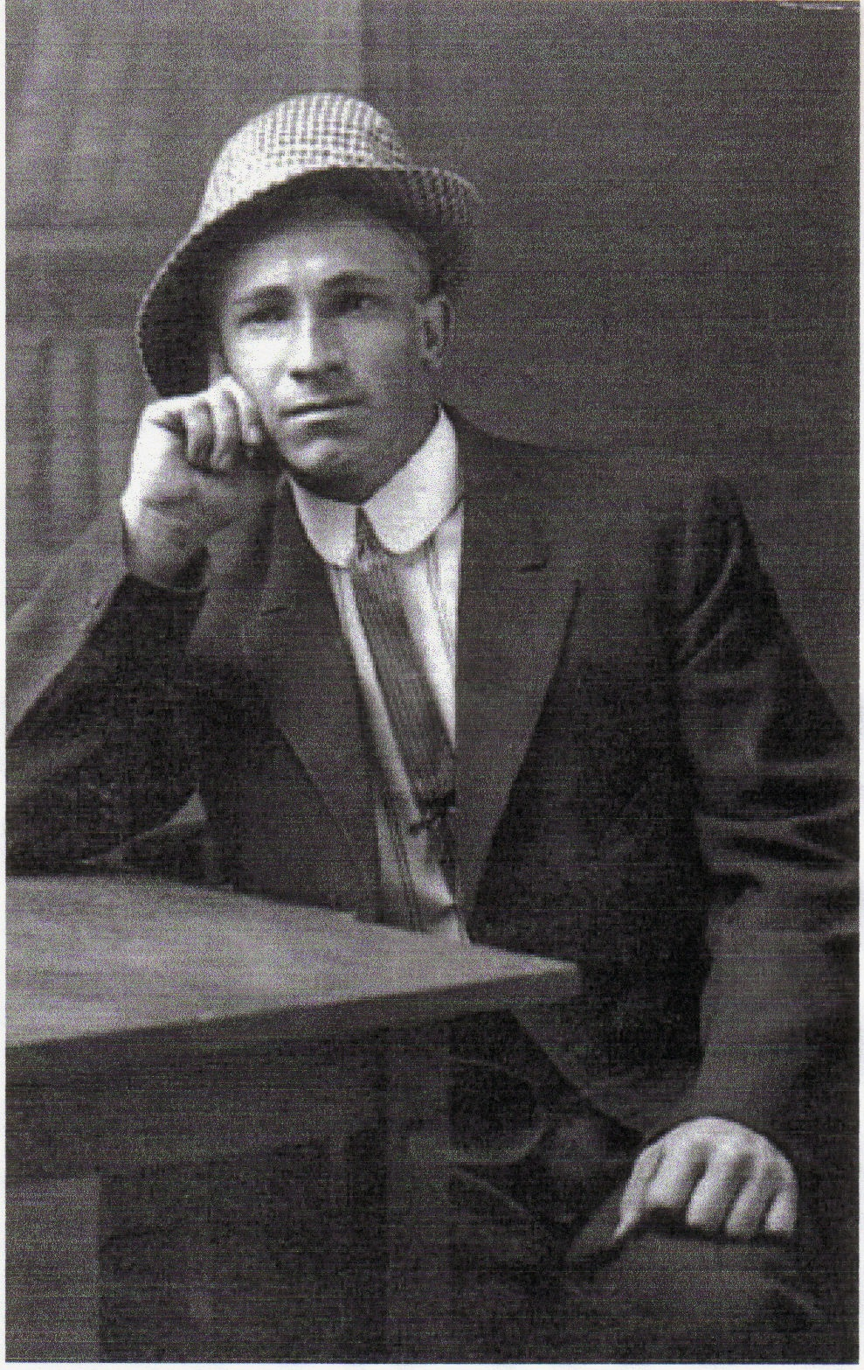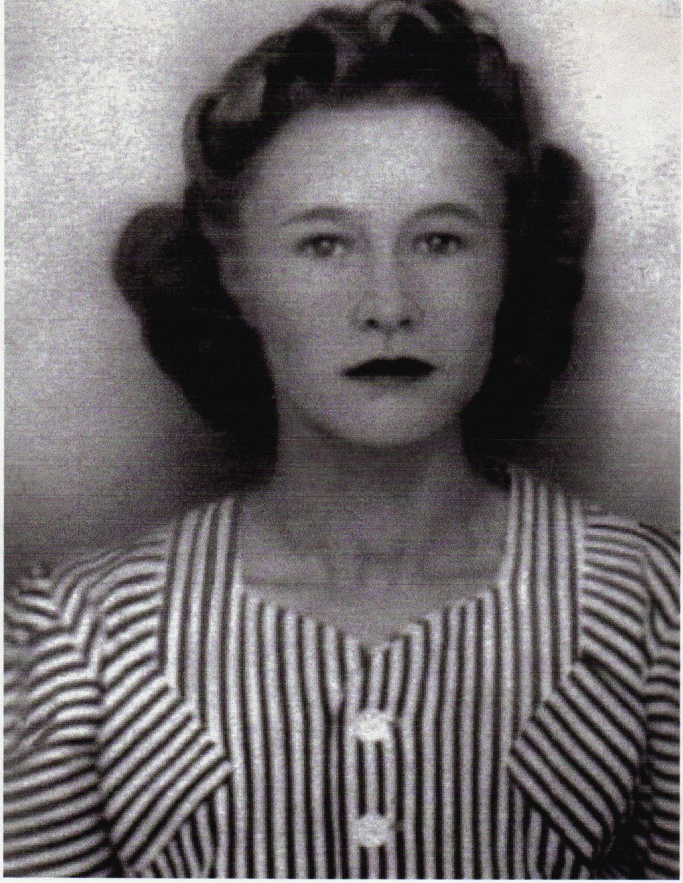

There is a file on these people. If interested, please contact Barbara Mills.

VANBIBBER-VANBEBBER-VANBEBER COUSINS REUNION

This year, the reunion will be dedicated to PARKER VANBEBER who will be 90 years
old this year.

The reunion is on May 21, 2006; 10 A.M.- ?????

Where: The home of Deboria Nadine V. Duvall
Phone: (918) 825-1985
Address: 343 SE 15th ST.
Pryor, OK 74631
Bring a covered dish, your camera, family history, and a lawn chair. Be prepared to do a lot of
Visiting.

Nadine: dnduvall@sbcglobal.net

Dear V.B. Family,

WOW! It is a big delight to receive the newsletter. Very Big Smiles here!

I have been studying my family for about 3 years, and I have found on “familysearch.org”
that Isaacs Jacobs VanBibber (born 1614) has a father listed as “Willem Van Vredenburch”,
and mother “Maria Van Waelenburch”.

My question is, why is this never mentioned in the VB Newsletter. We always stop at Isaac Jacob VB instead of going back to his 2nd great grandfather, “Baron Hugo Van Bredenburch”
(born 1525).

Isaac VanBibber and Sarah Davis
John VanBibber and Margaret Chrisman
Isaac VanBebber and Mary Martin
James Claiborne “Santiago” VanBibber and Anestaria Flores
Ricardo “Richard” VanBibber and Marina Nieto
Santiago “James” VanBibber and Elvira Recio
Louis Eliud VanBibber and Angelica Garza
Sylvia Ann VanBibber and Thomas Ponce

Family line done by: Gary R. Hawpe, July 2003; Vol. 6; No 9

Hello Patricia,

I am related to some of the VanBebbers. My line is:

Isaac Van Bebber m Hester Op de Graef
Jacob Isaac Van Bebber m. Christina
Debra Van Bebber (or Lisbet??) m. Herman Isaacs Op de Graef
Styge Op de Graef m. John Krey
Catharine Krey m. Christian Halderman
Chrisitan Halderman m. Magdalena Frey
Benjamin Halterman m. Fannie Funk
Christian Halterman m. Deborah Stauffer
Moses Halterman m. Ida Woods
William Halterman m. Ida Woods
Mary Halterman m. Charles T. Wolfram
Charles W. Wolfram
Do you know who the mother of Styge Op de Graef was? Debra or Lisbet? Both were
married to Styge’s father, and they were sisters, and I’ve seen both of them given as her mother.

Chuck Wolfram: cwolfram@prodigy.net



So nice to see a newsletter again. Thank you.
My husband, Henry Brown, was a great-grandson of John Calvin and Mariah Hall Vanbever and grandson to John’s daughter Gracie Vanbever-McCreary. Henry passed away on July 1, 2005, being born in 1931 in Harlan Co., KY to Henry Brown, Sr. and Hallie McCreary-Brown.

He always enjoyed reading the previous newsletters, and some stirred memories in him of people he met as a child.

Thank you again.
Annette Brown (of Indiana) : abrown4431@comcast.net

Patty,

Thanks for your efforts on the newsletter. I really enjoy reading the articles and notes.

My e-mail address will be changing soon. Can you add the following e-mail addresses for me.
Thanks.

Chris Van Bever (of Versailes KY) : cvanbever@adelphia.net & chris.vanbever@dinslaw.com

Hi Patty,

Thank you for continuing with our Van Bibber news.
I have missed it greatly.

Bev Tout: bever@bendbroadband.com

I am so happy to hear that the newsletter is coming back on line again. Kudos to you Patty, and all those that contribute to help keep the newsletter alive and thriving.

It’s such a great way to keep in touch with the “ORIGINAL 13 GROUP”, and also meet new cousins.

Thanks so much,
Elizabeth “Liz” Baker: lizbaker6221@yahoo.com

Hi, Was glad to see the newsletter in my mailbox. I am not a VanBibber, but down through the genealogy we, (Gary Hawpe and me) found out that the Lifords and Littrells fall into the family through Daniel Boone. I am still looking for the death date and burial place for Mary C. Liford Littrell.

I know it must be a hard task to put the newsletter together.

God Bless you,
Devota Littrell: LeeTaffy@aol.com

Glad to get your note the other day. I tried to get on genealogy.com, and there is no free site.

I am related to Yoakums in Tazwell, TN.

I have missed the newsletter.

Jane Longmire-Giesler: JaneGies@aol.com

PROBLEM SOLVED

Thank you Patty,

I have missed the VB Newsletter.

Good Luck to you, and thank you for taking the helm.

I put the site on my favorites.

Sincerely,
Jane Longmire-Giesler: JaneGies@aol.com

BOONE FAMILY REUNION; 2004; ASH GROVE, MISSOURI

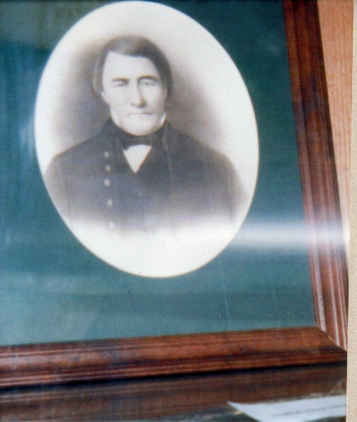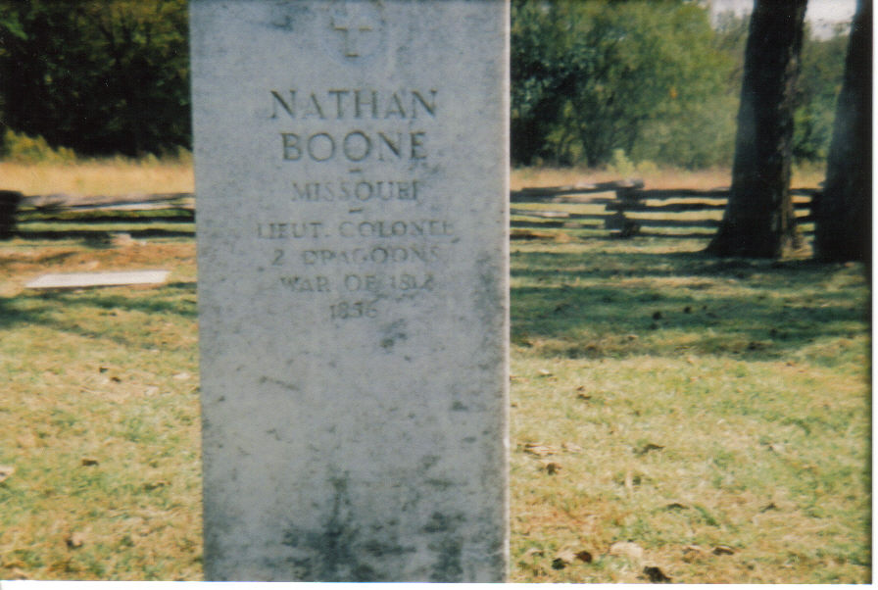

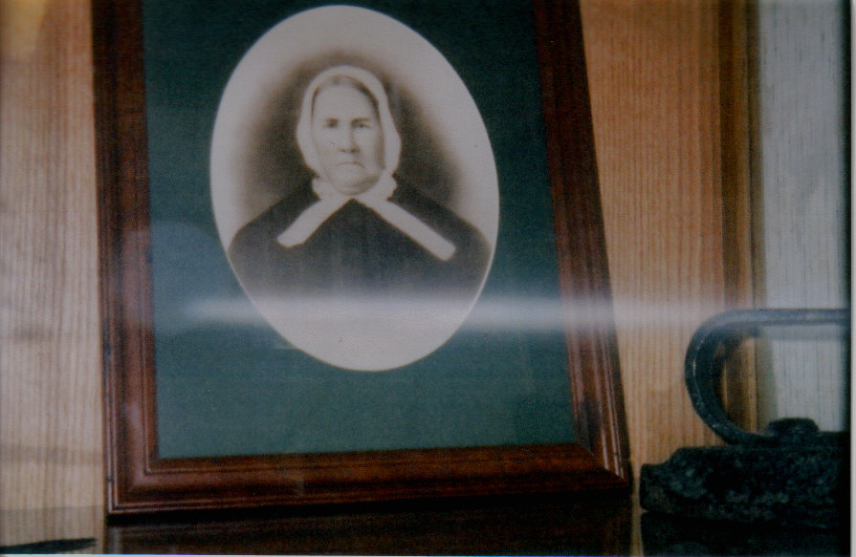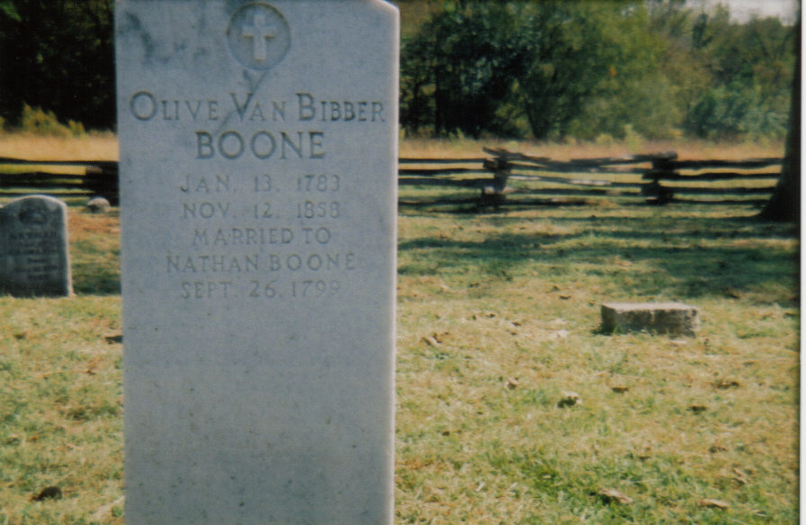

.

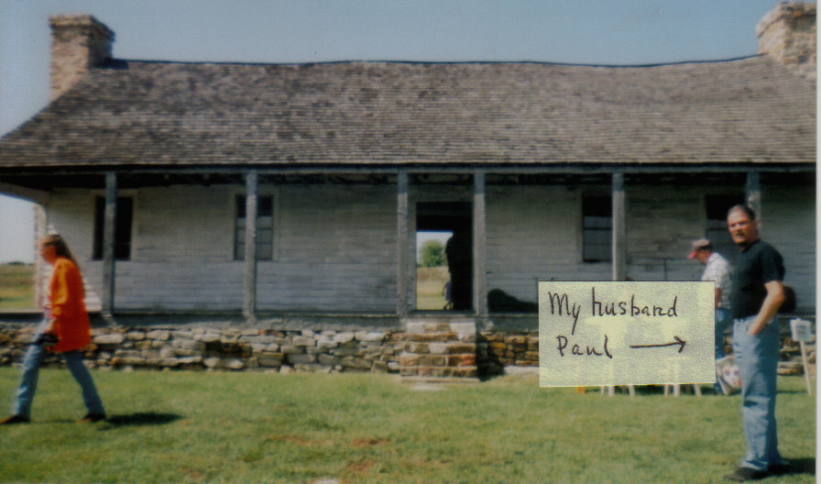

Home of Nathan and Olive Boone.
The house has 2 rooms and a loft. This is the back yard.

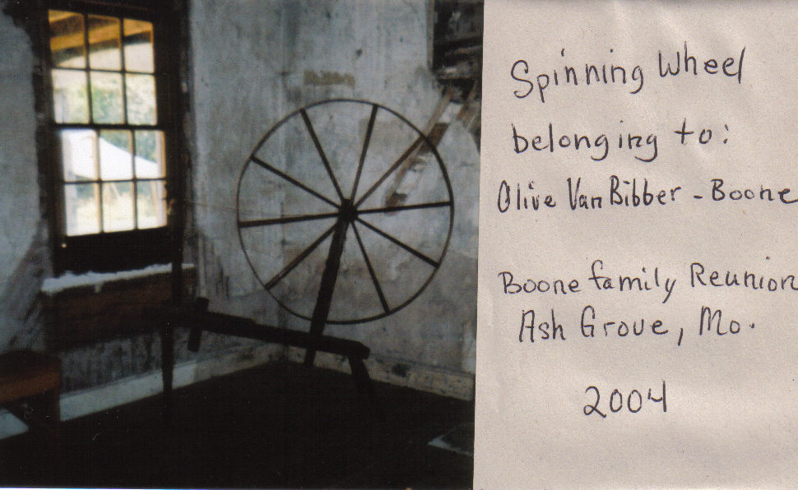

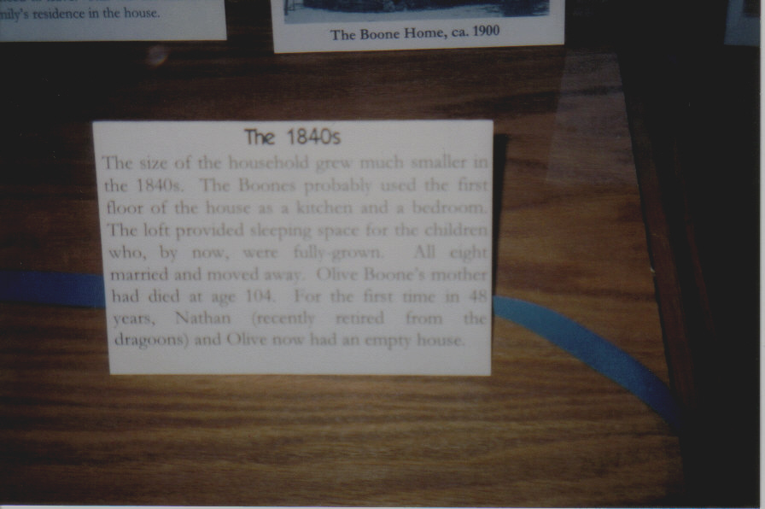

Photos submitted by: Patricia Van Bibber-Santillan

Please send any news articles and/or photos for publication to me ASAP. I would like to have the next addition to you in time for “Mothers Day”.

Also: Since Mother’s day is next month, I would like to dedicate the next edition to our “Mothers”, or grands, greats, etc. If you have any photos that you would like to share, or some special memory, send them and they will be posted.

Thank You,

Patricia Van Bibber- Santillan
Twitches123@wmconnect.com

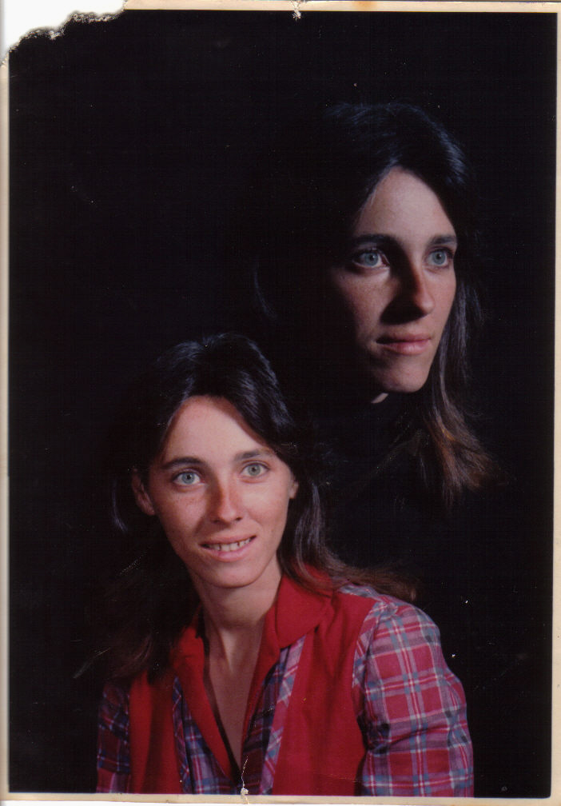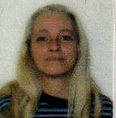

Patty, abt. 25 yrs. ago. Patty abt. 2 yrs. ago.

